

Olaf Court, Kensington Church St, London, W8 4DG

Outline Construction Methodology

Prepared by: Inam Anwar
Mayer Construction Ltd

On behalf of
Pirton LTD
September 2021

Contents

 | Project Introduction |  | 03
1.0 | Mayer company introduction |  | 05
2.0 | Program |  | 06
3.0 | Delivery controls |  | 07
4.0 | Site preparation |  | 08
5.0 | Materials handling and storage |  | 09
6.0  7.0  8.0  9.0 | Health and Safety  Superstructure  Fit out and external works  Environmental Control |  | 10  11  12  13
Appendix
A Tender Programme |  | 14
B Site Structure |  | 15 |  |  | For any further information please contact:
 |  |  |  |  | Lee Richardson (Project Manager)
 |  |  |  |  | Mayer Construction LTD
105 Harbour Yard
Chelsea Harbour
 |  |  |  |  |  |  | London SW10 0XD

Tel: +44 (0)20 7351 947 E-mail: lee@mayerconstruction.co.uk


Olaf Court – 50 A Kensington Church Street
Apartment Owners/Tenants/Residents

Welcome to our First edition of our newsletter to you all, we are Mayer Construction and have been appointed the Main Contractor for the works at Olaf Court.
We have started dome initial works onsite, surveying, and enabling works, and you have probably seen some of our team members in the building.
Over the next couple of weeks we will establish our site notice boards on the ground floor entrance, and set up our site offices and welfare buildings at the rear of the building complex.
I will be in touch with you all at some stage, and I have my details below if you need or have any questions or queries.
I will update the bullet points below with works affecting any of the communal areas, and our general works.

Mayer would like to test the water supply to each apartment in the week commencing the 6th of September over the length of the week depending on access, your availability.
Check electrical supply to each apartment, and mechanical ventilation.

I will leave all our contact details below, feel free to contact us at any time.
Kind Regards
Lee Richardson – Project Manager
Mob: 07951 285630
lee@mayerconstruction.co.uk

Mayer Construction Ltd – Office Site Manager
105 Harbour Yard, Chelsea Harbour Vidmantas Sumauskas
London, SW10 0XD Mob: 07895 817777
Tel: 0207 351 9473 vidmantas@mayerconstruction.co.uk
www.mayerconstruction.co.uk

Bird’s Eye view of proposed Olaf Court

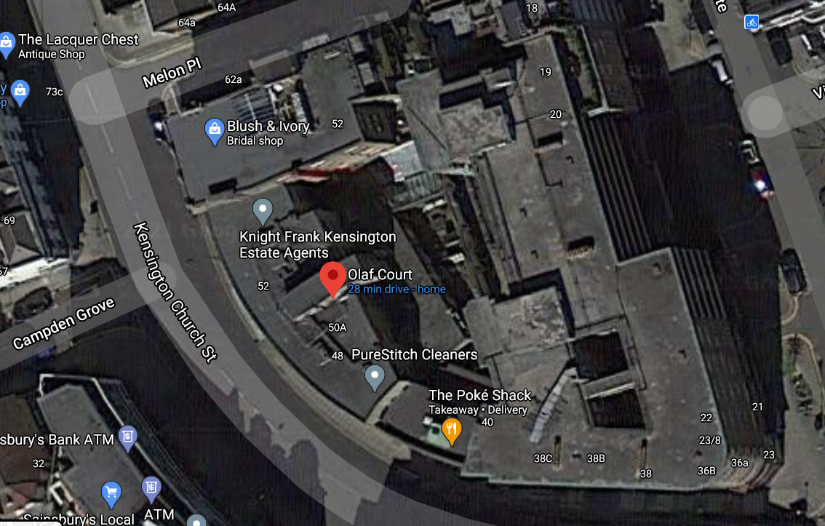

Project Introduction

This Outline Construction Methodology report has been prepared by Mayer Construction to provide you with an overview of the proposed construction methods relating to construction activities required for the redevelopment of the building, Olaf Court.

All works will be undertaken in accordance with the Royal borough of Kensington and Chelsea council relevant guidelines, and guidance as well as any other London and National policies, including the ‘National Planning Policy Framework’.

The project consists in the remodelling and front facades of the existing building, and the construction of the new apartments to the top of the existing structure, located on Kensington Church Street, situated in the middle of the borough of Kensington.
The existing building consists of several apartments over three floors with a centralised staircase and a passenger lift, with a communal entrance.
The works will include the demolition of some Existing structure to the property, and two new dwelling penthouses to be built on top of the existing structure.
There will be upgrades to all the existing windows to the exterior areas the front facade of the building and the communal areas.
The new building will provide an upgraded and new lift, a new entranceway and a complete remodel of the exterior finishes, bringing the building inline with current legislation and guidelines.
The scheme will also include an upgrade to front facade, currently a concrete angled finish, with a new streamlined stone and glass finish.

The scheme will bring a currently outdated property up to date with the latest smart home technology, as well as improve home living by introducing new energy efficient products, in a sought-after property in Kensington.

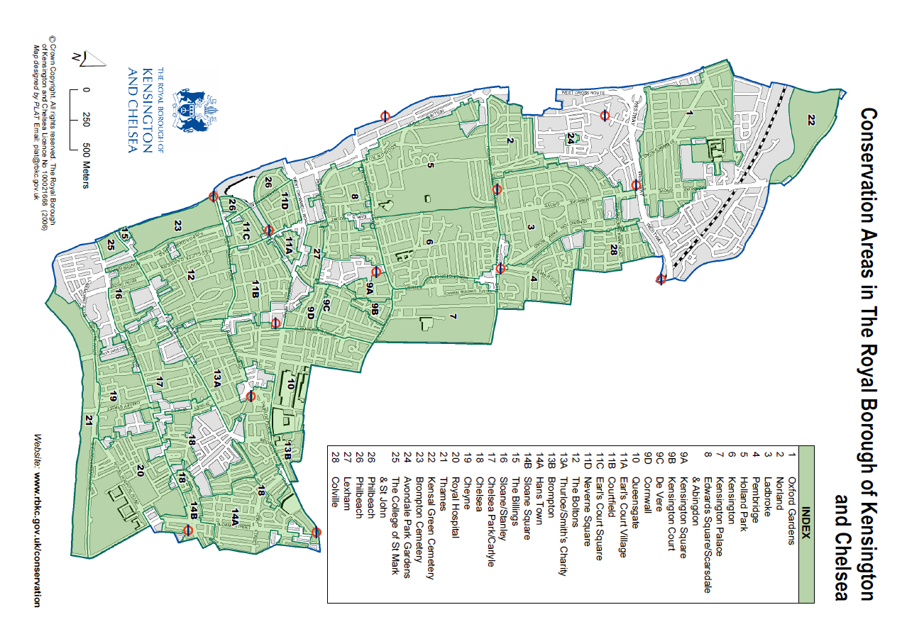
.

.

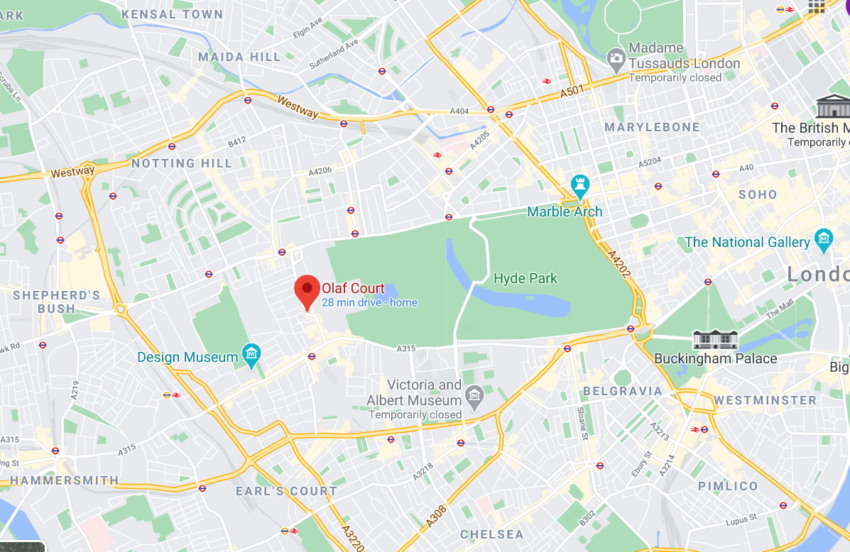

Location Plan







1.0 Mayer Company Introduction

1.1 Introduction

Background to Mayer Construction
Mayer Construction is a specialist building company, established with the sole objective of providing the highest possible
levels of quality, service and value for money to private clients with prime residences and commercial offices.

Our works include new-build, extension, refurbishment, fit-out and maintenance work in prime London areas, including Mayfair,
Belgravia,
Kensington & Chelsea, as well as the surrounding countryside.
We are very proud that the vast majority of our work is secured either by existing customers bringing us repeat business, or by these
people recommending our services to new clients.

We are completely flexible in our approach to the construction process, we are happy to work on a wide variety of contracts and
procurement routes, depending on a client’s particular needs. Most of our projects are carried out under a management style contract,
or some other form of two stage, open book process, where design and construction can be completed simultaneously, and procurement
can be managed in an open, collaborative manner, thus ensuring that we achieve the highest possible quality and the optimum program
period, all within agreed, managed budgets.

Mayer has a very loyal team of direct employees, which includes Project Managers, Quantity Surveyors, Engineers, Site Foremen and
Site labourers, as well as a highly skilled support team based in our Chelsea office.

We have particular experience in the high-quality fit-out and refurbishment of whole buildings as well as individual apartments, we have
carried out several projects similar to this one in the recent past and we are used to working within apartment buildings with very strict
working rules. These projects are described later in this document, along with a short list of other projects that we have carried out and
successfully completed.

All of the projects that we have completed or are currently working on, have similar characteristics to your project, and we hope that this
document will demonstrate our suitability to carry out the work for you.

1.2 Considered Constructors Scheme

Mayer Construction is committed to adhering to the highest level of practice and industry standards.

We have been proud members of the Considerate Constructors Scheme since 2017. The voluntary Scheme which has become the
industry standard asks contractors to abide by an agreed Code of Practice across their sites and business operations.
The scheme is particularly relevant in areas that are sensitive locations. The Scheme is concerned about any area of construction
activity that may have a direct or indirect impact on the image of the industry as a whole. The main areas of concern fall into three
categories: the general public, the workforce and the environment.

For more information, please refer to our website:
https://www.mayerconstruction.co.uk/

2.0
Program
2.1
Refer to Appendix A for the Mayer Construction TENDER Program
2.2
This Tender Construction Program details the process of the following stages:
- Preconstruction
    - Assist client team with procurement.
    - Advance Party Wall Award items if required.
    - Apply for all relevant permissions and permits to facilitate smooth transition to start on site.
    - Work with Architect and Structural Engineer on detailed design / Provisional Sum items.
    - Develop the construction process methodology.
    - Develop the schemes drawings and packages aligning the clients needs whilst incorporating all parties.
- Site set-up & Temporary Works
- Hoarding and scaffold License.
- Site Offices, Welfare and hoists.
- Temporary Services.
- Protection of the existing finishes.
- Demolition and Rubbish Removal/Recycling
    - Demolition Plan.
    - Removal of existing water tank.
    - Works to existing structure.
    - Demolition of existing lift car, Structure.
    - Waste Management Plan.
- Sub-structure Construction
        - New entrance to building.
        - Connections to existing underground services.
- New and Incoming Services Connections
    - Upgrades to existing supplies.
- Superstructure
- Low level Jack steel posts.
- Construction of Steel framework to main structure.
- Internal Posi-Strut joists to floor sections.
- New brickwork and isolated concrete structure.
- Timber roof structure to support roof finishes.
- External Envelope Rear and Front Facade
- Exterior window Package.
- Exterior specialist decorative stonework.
- Exterior wall cladding materials.
- Exterior specialist Glazing and Curtain wall.
- Decorative finishes to exterior package.
- Flat roof coverings
- Stainless Steel and Sedum roof finishes.

- Ground to Fifth Floor Works
- Internal stud and blockwork.
- Wet Trades.
- Communal staircases.
- M&E
        - Mechanical and Electrical First Fix.
        - Plant room for new penthouses.
        - Connection to existing services.
        - Heat recovery system.
- Fit Out
- Internal Works and Partitions.
- Specialist wall finishes.
- Ceilings and specialist lighting.
- Internal and External Doors.
- Mechanical and Electrical Second Fix.
- Main staircase.
- Specialist stone finishes.
- Floor finishes.
- Timber and joinery.
- Specialist decorative finishes.
- Internal glazing and External glazing.
- Bathroom fit out.
- Kitchen joinery.
- Specialist Joinery throughout.
- External Works
    - Front entrance and rear works.
    - Party wall and adjoining buildings.
    - External lighting.
    - External roof terrace.
    - Outside floor finishes.

3.0
Delivery Controls
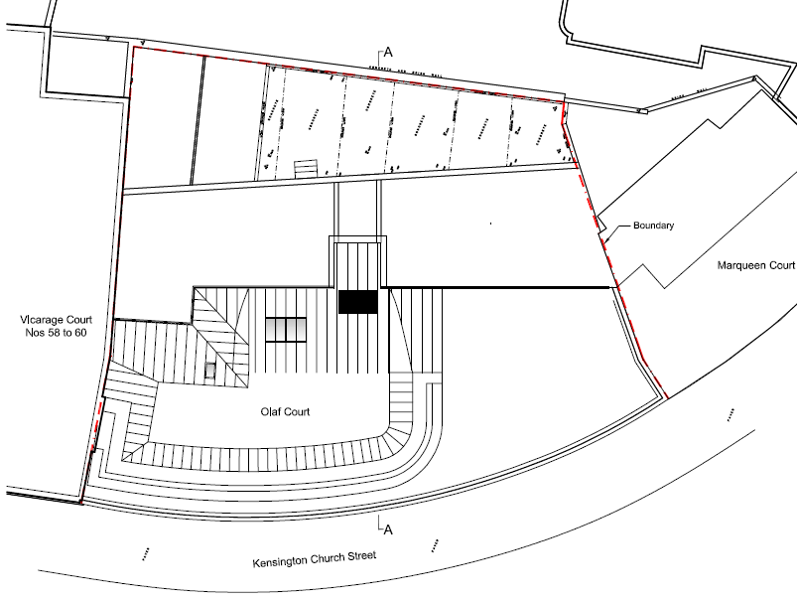

Site Office
Site Welfare

3.1
The site is located on a busy main thorough fare, Kensington Church Street, which joins High Street Kensington to Notting Hill.
There has been an outline Traffic Management Plan issued, and this needs to be advanced and incorporated into a master document.

3.2
Access and Traffic Routing

Deliveries
- Small deliveries will be directed to site with the approach from the north being preferable. These deliveries will be taken onto the pavement and brought through the main entrance.
- Large delivery vehicles will be directed to site with the approach from the North again, laying up in front of the site and having the natural flow of traffic move past them on their right-hand side. A traffic Marshall will control the deliveries and manage all processes.

The vehicular access routes are to be discussed with the Kensington’s Highways department prior to the commencement of the works.

3.3
Traffic booking and lock system
All construction traffic accessing the site front will be strictly controlled by Mayer Construction designated traffic marshals. The site management team will keep a detailed diary log of all drivers and deliveries

All contractors will be required to sign up to the Construction Logistics and Community Safety (CLOCS) initiative and commits to use contractors who are registered with the Fleet Operator Recognition Scheme
Mayer will also submit evidence of registration with and accreditation to the Freight Operator Registration Scheme (FORS)

3.4
Traffic Control
Based on the number of deliveries and traffic flow associated with the construction scheme it is considered that with a suitable vehicle call up procedure/booking system there would not be a requirement to hold vehicles on the highway network close to the site whilst other deliveries are being undertaken.

3.5
Road Safety
Vehicle access to the construction site will be managed to ensure vehicles access the site in a safe manner and with minimal impact on the local road network.

Site Welfare Position

Site Office

Pedestrian Access

Vehicular Access

4.0
Site Preparation

4.1
Site hoarding and security
While the construction works are taking place the site frontage will be secured, and Mayer will set up a Site Entrance board. This will include all associated signage (including Considerate Contractor Signage) which will be retained and adapted throughout the project in order to demarcate the construction area and to enhance security. Safety of the current residences and Site staff will be an absolute priority. As agreed onsite, hoarding will be painted and have lights signage. Its overall look to be neat and tidy in accordance with RBKC rules and regulations.
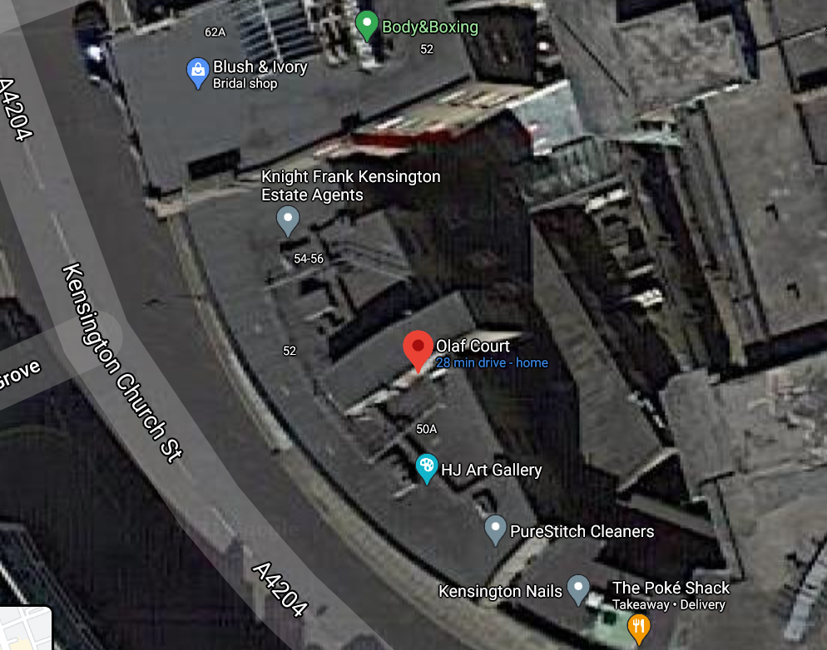

4.2
Site Office
Welfare facilities and site logistics
Site welfare facilities must be maintained for the duration of the work. This will be established with the use of Kitset lightweight buildings, that will be erected on the scaffold at the rear of the building.
Welfare facilities will be cleaned daily and maintained in good condition. During the current state of the country and the pandemic, all works areas will be thoroughly maintained, cleaned and sanitised on a daily basis, to ensure a safe working environment, following all COVID-19 strict government guidelines and have a specialist H&S manager, who will oversee this on site.
Site Welfare
4.3
Security Lighting
Site lighting will be at the minimum luminosity necessary to enable the safety and security of the construction site. Where appropriate, lighting to site boundaries will be provided and illumination will be sufficient to provide a safe route for the passing public. Where appropriate, lighting will be activated by motion sensors to prevent unnecessary usage. It will comply with the Institute of Lighting Professionals' Guidance notes for the reduction of obtrusive light. In determining any temporary construction lighting arrangements for the site, due consideration will be given by the Principal Contractor to residents and other sensitive receptors that may experience a nuisance by the light.

4.4
Scaffolding and sheeting
During the works on site, the secure hoarding will be adapted, upgraded and updated as required to enable works with neighboring properties, whilst maintaining ability to carry out the works required at the boundaries.
A Scaffold alarm will be put in place front and rear for added security.
Monoflex sheeting to the gantry level only, and netting to all other areas of occupied apartments will be debris netting. New construction areas will be monflex. The front and rear Scaffold will impede light, so netting may be advisable.

5.0
Materials Handling and Storage

5.1
Access to the Site Place for construction/delivery vehicles is limited, due to the restrictions of Church street.
Accordingly, and also considering the traffic constrains of the area, when possible, deliveries will be organized with small trucks or vans and materials for delivery and removal to and from the site will be manually handled to a designated loading area on site. Due to the restricted nature of the site access, delivery and storage of loose materials will generally be in small batches capable of being man-handled. Delivery and storage of component materials will also be in small batches and deliveries will be on a ‘just-in-time’ basis. Larger deliveries will be slewn via mobile crane from roadside and onto site, to our construction methodology. A lifting plan will be put in place prior to any works commencing.

5.2
Upon the demolition of the existing building, materials can be stored further on site, with a materials hoist positioned on the front scaffold and as required for each construction phase. Material distribution within the structure will be dealt with using this materials hoist. A Niko Rail System could then be attached to the temporary roof structure, to slew materials from the fixed gantry lifting point.

5.3
Construction activities, including the storage and handling of materials on site will be in accordance with the EA Pollution Prevention Guidance (PPG) documents

5.4
To reduce noise and vibration, careful handling of materials and waste to minimize dropping from heights. Noise and vibration monitors can be installed to monitor any disruptions.

5.5
The handling, use and storage of hazardous materials will be undertaken in line with the current best practice. C.O.S.H.H. data sheets will be held on site for the duration of the project.

5.6
Materials and waste will be stored in appropriate conditions to prevent damage or contamination of storage areas. All hazardous materials including chemicals, cleaning agents, solvents and solvent containing products will be properly sealed in containers at the end of each day, prior to storage in appropriately protected and bunded storage areas. Wait and Load skips will be called off as required, when enough labour is on site to minimize the stoppage time, whilst maximizing the loading capabilities.



6.0
Health and Safety
6.1
The construction phase plan (CPP)

The construction design and management regulation (CDM regulations), require that,
Before the construction phase begins, the client ensures that the principal contractor
Produce a details construction phase plan.

The construction phase plan (CPP) record arrangements for magauing significant health
and safety risks associated with the construction works. This document should outline
the health and safety arrangements and site rules taking into account all the different
activities taking place on site and, when applicable, must include specific measures con
concerning any work involving the particular risks listed below:

Works that put workers at risk where the risk is particularly aggravated by the nature
of the work (eg falling from a height).



Work which puts workers at risk from chemical or biological substances constitiung a particular


danger to the safety or health of workers or involving a legal requirement for health

monitoring.

Work involving the assembly or dismantling of heavy prefabricated components

6.2

Construction phase plan description

As principal contractor for the works at Olaf Court, Mayer will prepare a construction phase plan

Which will respond to the following requirements:

A description of the project, project key dates and details as well as key members of the project team.

The health and safety aims for the project

Site Rules

Arrangements to ensure cooperation between project team members and coordination of their work

Arrangements for involving workers

Site induction system

Welfare facilities

Fire and Emergency procedures

Control of site risks

7.0

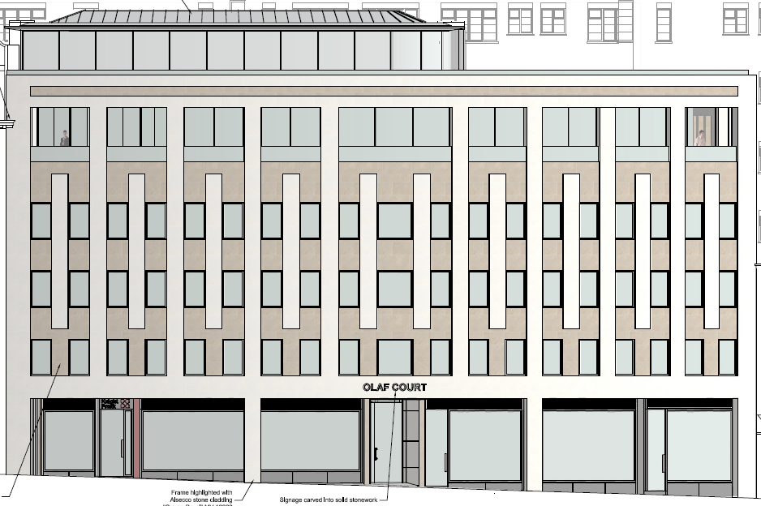

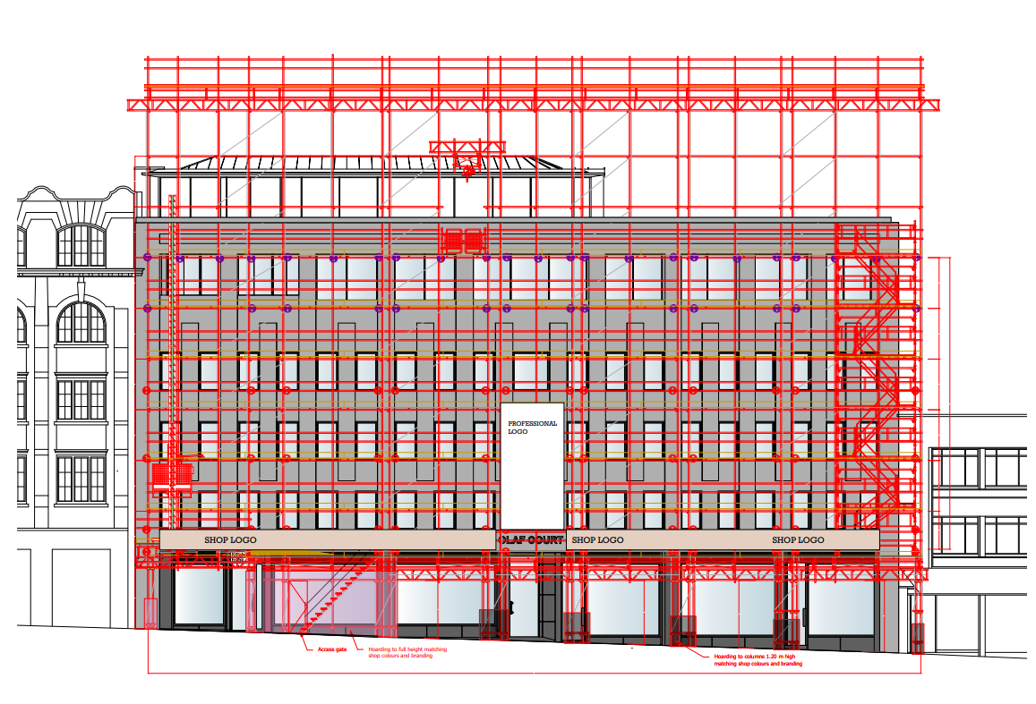

Superstructure

7.1
Following the removal of the existing structure on the roof, the pedestal steelwork can be installed to their Grid line positions and survey heights. The transverse beams and floor structure beams can then be installed to all of the 4th and 5th floor areas, and the associated columns can follow on.
Care will be taken to set out sections to miss existing services, and holes are to be fabricated off site for sequenced M & E service coordination.
All steelworks will be installed to a sequenced order, and the following floor structure and curved beam sections will follow on.
Pozistrut beams will be installed with temporary floor structure to form working platforms to assist with the phased construction sequences, and where required bird cage scaffolds can be installed.
A Haki staircase will be installed as required to make access for staff and materials to move from floor to floor, and scaffold will form edge protection whilst works are underway.
All levels and setting out points will to be Architects drawings, incorporating grid lines, and structural Engineers designs.

7.2
Roof structures
The construction of the flat roof sections, main roof sections will be installed once the steel frame is complete. The main roof sections will be joisted out and trimmed for skylight openings in conjunction with architectural drawings, and engineers specifications. Soffit and eaves details will also be installed to complete the roof substructure.

7.3
Front Façade
A separate construction team will work on the front façade, along with designated subcontractors. These works, will have their own sequencing which will be developed by the on site management, with all parties included. The demolition of the existing concrete façade, will be tasked to a specialist contractor and incorporate all health and safety, structural engineers design, and follow on works. Upon completion of the demolition and removal of non required items, a sequence of events, of window installation, hand & rail system and stone cladding by a specialist stone contractor will be undertaken. As this package of works is extensive, particular emphasis will be placed by Mayer Construction on this works package.

8.0
Fit Out and External Works

Fit Out
8.1
The internal fit out will progress with first fix to electrical and mechanical as the building envelope is nearing completing. Ply flooring can be laid to all areas and internal partitions can be advanced looking to start the first fix drylining elements. Upon all mechanical and electrical first fix installation sign offs, and record instillation drawings being produced. The drylining package can then be completed incorporation all elements of internal glass works, staircase, bathroom layouts, coffered ceilings and internal elements to the architects specified drawings. Plastering will follow on and will incorporate shadow gap details and LED preoperatory systems incorporating decorative moldings and architectural features. Second fix carpentry will follow with specialist timber finishes and door sets, incorporating all architectural timber moldings and finishes. Timber flooring will be installed to the floor finish schedules and will be protected. Custom made joinery will follow to all areas and incorporate the bespoke Kitchen. Bathrooms will be fitted out and tiled in accordance the finishes schedules with tiling and stone, and specialist wall finishes. Painting and wallpaper finishes will follow on upon completion of all major internal elements being completed. Second fix electrical and mechanical will follow on as the building nears completion, carpets will be laid on the upper floors and be protected. Upon all elements being complete a snagging program will be initiated and implemented onsite with the architectural team. A de-snag period will be nominated, and these works will finalize the internal areas.
Landscaping and Garden
8.2
Landscaping the external areas will incorporate the irrigation system, lighting, planting schedule to the main garden and front areas. All items will be installed to the architect’s details and designed layouts.
Water features and external timber works will follow on incorporating the external paving and lighting.
Water Tank
8.3
The existing water tank removal will coincide with our construction plan, to have a temporary water service tank installed for a smooth transition and change over of supply. This will be co-ordinated on site with our M&E Consultants and contractor, to ensure that no loss of service or pressure to the tenants services will be experienced. Upon completion, the temporary tank will be removed from site. This will be located at the rear of the property whilst the works are carried out.

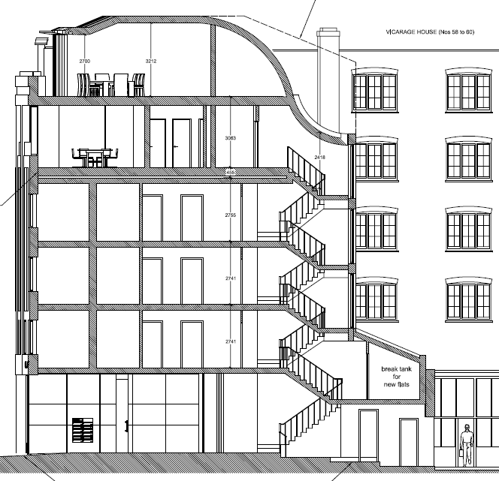

Proposed Section Details

9.0
Environmental Control

9.1
To comply with the requirements of the RBK Council environmental regulations and with the planning conditions for monitoring and mitigating noise associated construction works in this location, Mayer will put in place an Environmental Management Plan which will compile the required strategies to mitigate as much as possible noise vibration and dust during the construction works

9.2
Noise
Noise limits are to be set according to current legislation, Mayer will establish the type of plant and methodology to keep noise within legal limits and avoid any disruption to the neighbouring properties.
Demolition and construction activities will be restricted to observe the RBK Council quiet hours time restriction, being the hours of 08:00 – 18:00 Monday to Friday ONLY. Therefore, no work will be undertaken at unsociable hours when the impacts of noise on neighbours would be greatest
Building work which can be heard at the boundary of the site will not be carried out on Saturdays
The works are to take place within the confines of the site and any scaffold should be protected with fire proof Monaflex type sheeting/Netting.
Mayer would like to use an existing power source onsite.

9.3
Vibration
To reduce as much as possible the vibrations and as per the structural engineers recommendations, Mayer will implement the following key measures:
Try to avoid when possible operations that produce vibration happening simultaneously
Aim to use low-vibration techniques such as sawing in preference to pneumatic breaking
- Where possible, avoid operations producing vibrations near adjacent occupied premises

9.4
Dust and Air Quality
Mayer will ensure the provision of appropriate hoarding and scaffolding sheeting to ensure dust control within the building site. The surrounding roadway and access paths will be monitored for excessive muck deposits from demolition activities are cleaned on a daily basis.
Mayer will be committed to control and limit dust and exhaust emission during the construction works as far as reasonably practicable and following Best Practice Management guidance.

9.5
Movement & Safety
A touch access keyless door system will be installed to the top of the staircase, to ensure only site personnel can gain entry to the works area. The lift will be useable for the beginning part of the project. Prior notice will be given to the residents when the lift is to be decommissioned. During the period when the lift is not available, Mayer Construction will liaise with all tenants to ensure they are comfortable with access/egress, Covid-19 requirements, and security of the building. It would be preferable to use the adjacent shop to muster and co-ordinate tenants’ access and egress during busy worktimes and sequenced communal area works. The disruptions will be kept to a minimum.





Appendix A Tender Program separate attach

Appendix B
Mayer Site Structure

OLAF COURT_SITE STRUCTURE

